PROMISE & PRACTICE · DEEP DIVE · SOURCE ANALYSIS
The New York City Draft Riots — A House Divided
Why the City Burned
Name: ______________________________ Period: _____ Date: ________________
WHAT I CAN DO TODAY I can read primary sources about The New York City Draft Riots — A House Divided, weigh who made each one and why, and use evidence to answer historical questions.
Directions. Big events are almost never caused by just one thing. Sort the pressures that combined into five days of violence

THE SOURCES
THE IMAGE · 1863 — The burning of the Colored Orphan Asylum
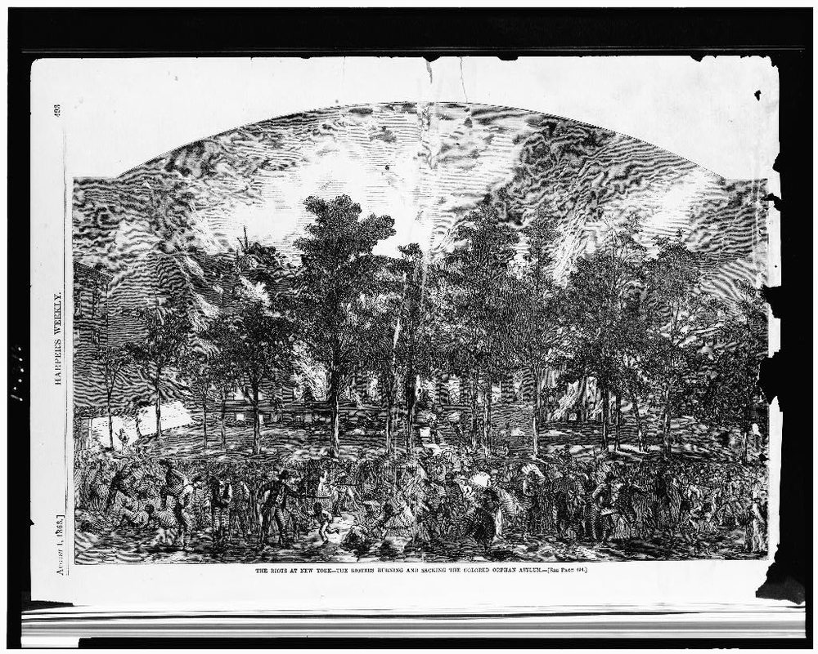
More than 200 Black children lived here. The building was looted and burned; the children escaped out the back and were sheltered by a police station
“The Riots at New York — the Rioters Burning and Sacking the Colored Orphan Asylum” — wood engraving, Harper's Weekly, August 1, 1863, public domain (Library of Congress).
SOURCE · THE DRAFT LAW · 1863 — The $300 clause
“…any person drafted … may, on or before the day fixed for his appearance, furnish an acceptable substitute … or he may pay to such person as the Secretary of War may authorize … a sum not exceeding three hundred dollars … for the procuration of such substitute.”
— Enrollment Act of 1863. Public domain
— Enrollment Act of 1863. Public domain.

YOUR WORK
QUESTION 1 STEP 1 · LIST THE CAUSES
The lesson describes several pressures behind the riots. List four different causes that combined to produce the violence.
____________________________________________________________________________________________
____________________________________________________________________________________________
____________________________________________________________________________________________
QUESTION 2 STEP 2 · “A RICH MAN'S WAR”
Using the draft-law source, why did the $300 exemption feel so unjust to poor workers?
☐ A. it applied only to the rich
☐ B. it was far too small to matter
☐ C. it freed enslaved people
☐ D. it let the wealthy buy their way out, leaving the poor to do the fighting
QUESTION 3 STEP 3 · CAUSES WITH A TARGET
The riot began against the draft but quickly targeted Black New Yorkers. Using the image and the lesson, explain how racism and job competition turned an anti-draft riot into a racial massacre.
____________________________________________________________________________________________
____________________________________________________________________________________________
____________________________________________________________________________________________
____________________________________________________________________________________________
QUESTION 4 STEP 4 · WHY IT MATTERS
A student says, “The riots happened because of the draft.” Using multiple causation, explain why that answer is too simple, in two or three sentences. What does it leave out?
____________________________________________________________________________________________
____________________________________________________________________________________________
____________________________________________________________________________________________
____________________________________________________________________________________________
Promise & Practice · ShadowDog Digital Studios · Unit 2

TEACHER ANSWER KEY — The New York City Draft Riots — A House Divided

QUESTION 1: Open response.
Look for a response along the lines of: “1)… 2)… 3)… 4)…”
QUESTION 2: Correct — D. it let the wealthy buy their way out, leaving the poor to do the fighting
Right. At nearly a year's wages, $300 let the wealthy simply buy their way out — so the burden of fighting fell on those who could not pay. Hence ‘a rich man's war and a poor man's fight.’
QUESTION 3: Open response.
Look for a response along the lines of: “The anger shifted to Black residents because…”
QUESTION 4: Open response.
Look for a response along the lines of: “Blaming only the draft is too simple because…”

